BRYAN YANTO

S103486658

Engineray Project

Company

Contents

TAP ENGINERAY 2

User Manual – Companies Page 2

First Page 2

Index Page 2

Login Page 4

Sign up Page 4

Find engineers 5

My Candidates 8

Hired Engineers 10

Contact Us (improvement) 10

# TAP ENGINERAY

Project Description

The purpose of this project is to build and develop a website called EngineRay, a job search and recruitment platform designed for multiple companies and engineers who are job seekers. Engineers can create their own profiles, which will be enriched by the vetting data generated by EngineRay. Companies as employers can search and evaluate candidates' profiles based on certain criteria. In addition, the client EngineRay will have access to this data and act as an administrator.

# User Manual – Companies Page

## First Page

The first landing page that we are making for EngineRay is using a similar idea compared to their original webpage. And we also added a couple of pictures and a blue theme to match it.

First time users could press the start hiring button to see the introduction of the webpage.

## Index Page

Since EngineRay has a page which introduces the functions of their website, we also decided that it is a great idea to put the page so that new users will know what things that will be provided and needed in order to use this website to their advantage.

This page is served as the introduction to the companies that would like to use this website to find any potential engineers that is suitable for them.

There are some mock interviews and problem-solving videos that can be used as a reference for companies.

## Login Page

I have made login page, however, this page will be covered by backend.

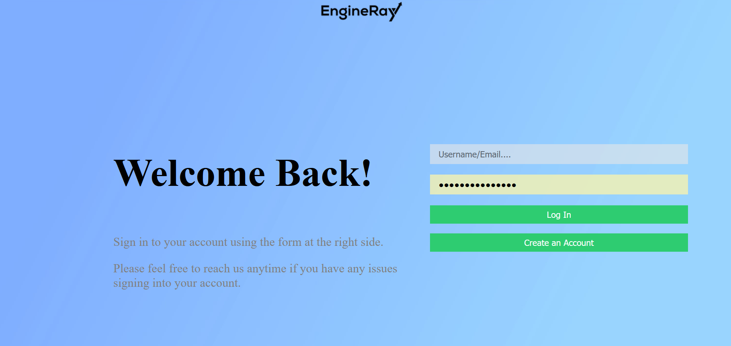

## Sign up Page

I have made sign up page, however, this page will be covered by backend.

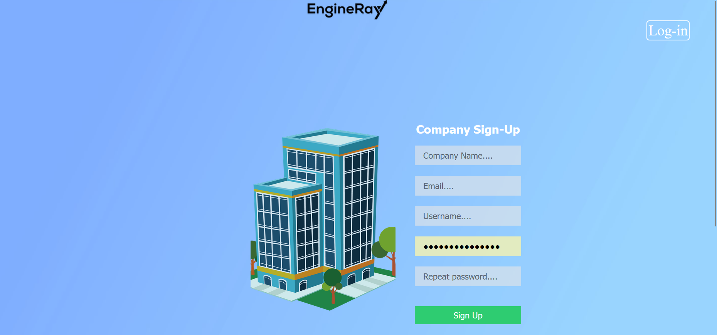

## Find engineers

Based on client requirements, the most crucial function is to Search (query) function and filters should be available on the webpage.

The query function in PHP is a powerful tool for interacting with databases. It allows developers to send SQL commands to a database and retrieve the results in the form of an object or an array. The query function takes in a SQL statement as its argument, which is executed by the database engine. The function returns the result of the query as an object or an array, depending on the database driver being used. The query function can be used to retrieve data from a database, update or delete data, or insert new data into a database. It is a crucial function in PHP's database API and is essential for building dynamic web applications that interact with databases.

The search/Sort filter includes five search bars, occupation, my skills, year of experience, preferred annual salary, and start date. Clients from the company side can search engineers based on these conditions and their requirements.

The data was retrieved from the engineer side database.

There are several sort on this page (Improvement)

Occupation drop lists: This is to sort out based on the occupation list that already put inside the data

Multiple selections for My skills: users can pick more than one skill to query the proper engineers.

Year of experience will sort the minimum experience required by the company

Preferred annual will sort based on the range that the engineers have at the moment.

Start date will sort the dates and show the dates before the dates that the company choose.

After the users input the sort data, it will still retain the history of the sort, so that the users don’t have to retype it.



This plus sign will be used to add candidates from find engineers to the My candidates list. It serves as a like button.

## My Candidates

After the company has added each candidate from Find engineers page, each profiles will be added into added candidates tab in My Candidates page so that they could filter which candidates meet their criteria.

After they see their candidates, if companies want to proceed, they could press the interview candidates’ button to see the engineer’s availability and those candidates will be transported into the interviewed candidates tab. While if they don’t need the candidate, they could press “X” button so that they could remove those candidates from the page. Companies have 2 options after which whether to accept or reject the candidates after the interview.

The search function on the side, it will search any words that is matched with the data inside the interviewed Candidates page.

After companies accept the candidate, the candidate will be moved into the accepted candidates tab.

Once companies accept candidates, candidates will receive a job offer from companies and they can choose whether to accept or reject the offer. If both parties accept the offer, then EngineRay will send both contracts to both companies and engineers to sign. From the attachment, the company can be redirected to docusign to sign the contract.

The search function on the side, it will search any words that is matched with the data inside the hired engineers page.

Docusing will be automatically opened. Users can drag the file into the DocuSign to sign the file.

## Hired Engineers

The Hired engineers page will show all the engineers that have been hired from the company and it will be sorted from the newest to the oldest.

The search function on the side, it will search any words that is matched with the data inside the hired engineers page.

## Contact Us (improvement)

This page will be the bridge between users and admin. Because users already login, they could just submit the message to the admin.

